In lab question 1 (6a):
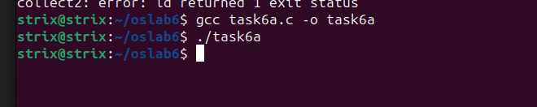
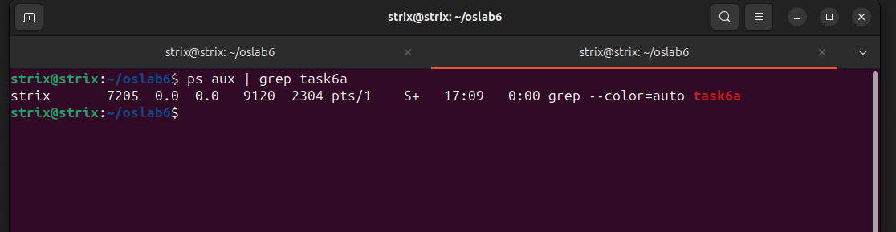

Modified code:
#include <sys/types.h>
#include <stdio.h>
#include <string.h>
#include <unistd.h>

#define BUFFER_SIZE 25
#define READ_END 0
#define WRITE_END 1

int main(void)
{
char write_msg[BUFFER_SIZE];
char read_msg[BUFFER_SIZE];
int fd[2];
pid_t pid;

if (pipe(fd) == -1) { // create a pipe
fprintf(stderr, "Pipe failed");
return 1;
}

printf("Enter a message: ");
fgets(write_msg, BUFFER_SIZE, stdin);

pid = fork();

if (pid < 0) { // error occurred
fprintf(stderr, "Fork Failed");
return 1;
}

if (pid > 0) { // parent process
close(fd[READ_END]);
write(fd[WRITE_END], write_msg, strlen(write_msg) + 1);
close(fd[WRITE_END]);
} else { // child process
close(fd[WRITE_END]); // close the unused end of the pipe
read(fd[READ_END], read_msg, BUFFER_SIZE); // read from the pipe
printf("read %s", read_msg);
close(fd[READ_END]); // close the read end of the pipe
}

return 0;
}
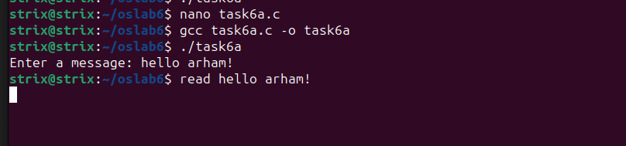

In lab question 2 (6b):
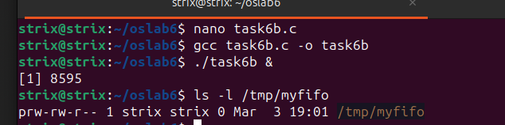
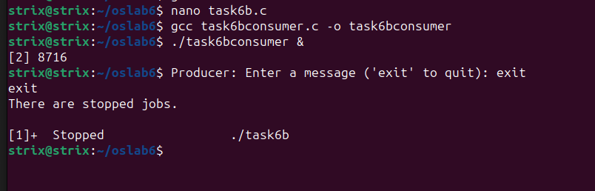
In lab question 3 (6c):
- Producer code:
#include <stdio.h>
#include <stdlib.h>
#include <string.h>
#include <fcntl.h>
#include <sys/shm.h>
#include <sys/stat.h>
#include <sys/mman.h>
#include <unistd.h>

int main() {
const int SIZE = 4096; // size (in bytes) of shared memory object
const char *name = "OS"; // name of the shared memory object
const char *message_0 = "Hello,"; // strings written to shared memory
const char *message_1 = "World!";

int fd; // shared memory file descriptor
char *ptr; // pointer to shared memory object

fd = shm_open(name, O_CREAT | O_RDWR, 0666); // create the shared memory object

ftruncate(fd, SIZE); // configure the size of the shared memory object

ptr = (char *) mmap(0, SIZE, PROT_READ | PROT_WRITE, MAP_SHARED, fd, 0);

// write to the shared memory object
sprintf(ptr,"%s",message_0);

ptr += strlen(message_0);

sprintf(ptr,"%s",message_1);

ptr += strlen(message_1);

return 0;
}
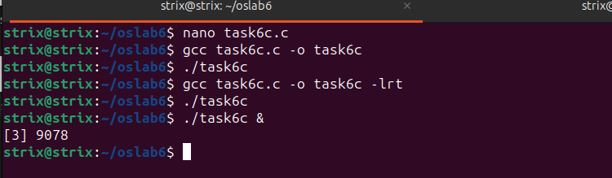
2) Consumer code:
#include <stdio.h>
#include <stdlib.h>
#include <fcntl.h>
#include <sys/shm.h>
#include <sys/stat.h>
#include <sys/mman.h>
int main() {
const int SIZE = 4096;
const char *name = "OS";
int fd;
char *ptr;
fd = shm_open(name, O_RDONLY, 0666);
ptr = (char *)mmap(0, SIZE, PROT_READ | PROT_WRITE, MAP_SHARED, fd, 0);
printf("%s", (char *)ptr); // read from the shared memory object
shm_unlink(name); // remove the shared memory object
return 0;
}
2)
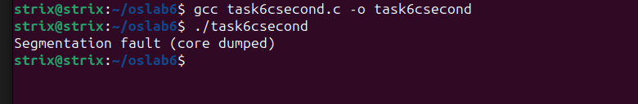

Why not working?
The segmentation fault in your code might be occurring due to several reasons. One potential issue is that you are trying to read from shared memory that might not have been properly created or initialized.
Ensure that you have a process that creates the shared memory segment with write permissions (O_CREAT | O_RDWR) and writes data into it before attempting to read from it in this process. Without proper initialization, reading from shared memory might result in a segmentation fault.
- By creating fork() system call in producer code.
Modified producer code:
#include <stdio.h>
#include <stdlib.h>
#include <string.h>
#include <fcntl.h>
#include <sys/shm.h>
#include <sys/stat.h>
#include <sys/mman.h>
#include <unistd.h>

int main() {
const int SIZE = 4096; // size (in bytes) of shared memory object
const char *name = "OS"; // name of the shared memory object
const char *message_0 = "Hello,"; // first message
const char *message_1 = "World!"; // second message

int fd; // shared memory file descriptor
char *ptr; // pointer to shared memory object

// Create the shared memory object
fd = shm_open(name, O_CREAT | O_RDWR, 0666);
if (fd == -1) {
perror("shm_open");
exit(EXIT_FAILURE);
}

// Configure the size of the shared memory object
if (ftruncate(fd, SIZE) == -1) {
perror("ftruncate");
exit(EXIT_FAILURE);
}

// Memory map the shared memory object
ptr = (char *)mmap(0, SIZE, PROT_READ | PROT_WRITE, MAP_SHARED, fd, 0);
if (ptr == MAP_FAILED) {
perror("mmap");
exit(EXIT_FAILURE);
}

// Write to the shared memory object
sprintf(ptr, "%s", message_0);
ptr += strlen(message_0);
sprintf(ptr, "%s", message_1);

// The shared memory object remains open until it's closed by the consumer

return 0;
}

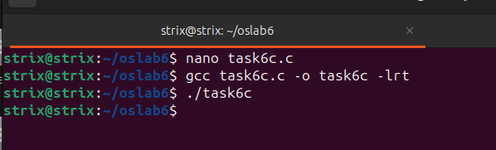
4)
